  - Each week you should be reading to your Mum, Dad or another adult every day and practicing your spellings each day using look cover write check. This only takes a short amount of time especially when you are practicing every day, but this will help with all your written work in school. The homework on the menu below has nine possible homework tasks you can do, you need to choose six to complete, taking two weeks to complete each one. The space shuttles show you how many skills or thinking you need to do to complete tasks.
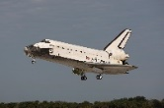 | 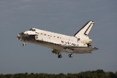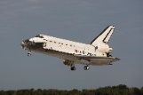 | 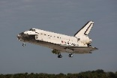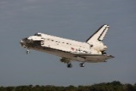
www.purplemash.com - Rocket  (design a rocket) | www.purplemash.com – 2Logo  (give instructions to move a ‘turtle’ in a background of your choice) | Research an astronaut and create a poster
Draw a picture of earth (as a cycle) labelling water and land. | Write a story about going to the moon and your adventures on the moon. | www.purplemash.com – Little Astronauts template (create an information sheet about space)
Look at the night sky and draw the pattern of the stars. Can you name any of the patterns? | Draw and label the plants and animals that are in your garden habitat. | www.purplemash.com – Neil Armstrong  (Using what you have learnt about the first man on the moon, write a report as though you have flown in space and walked on the moon)

