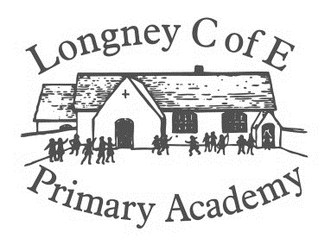

Outcome

To write and perform poetry that links to the forests.

RE: What does it mean to belong to a faith community?

**Values:**

Term 1: Respect and Thankfulness.

Term 2: Courage and Trust.

Key Question: Why Are Forests Important?

Synopsis

# Skylark class will be learning about forests. Both forests in the local area and the main forests around the world.

# What has changed in the lifetime of a tree?

# How we need to look after the forests to protect every living thing.

**Ethiopia** What is the landscape like? What are the forests like in Ethiopia? What is life is like for the people?

Whose responsibility is it to protect the forests?

RE: Who do Christians say made the world? **Harvest**

Opportunities for Critique and Redrafting:

When designing and making the model shelters.

PSHE:

Friends and Family

Kindness and anti-bullying

Internet Safety

Audience:

Our School Community

Parents Celebration Worship

Where are the forests in our area?

Who or what lives in a forest?

What does the forest look like in the different seasons?

How do we know when summer is over?

What is special about the habitats in a forest?

How can we observe the habitats?

Do the habitats change through the seasons?

What can we use from a forest?

Is wood better to use then other materials?

Launch:

Trip to Westonbirt Arboretum – 16th September 2019

Walk around the village.

How has life changed in the lifetime of a tree?

How old can trees be?

Are there any very old trees in Longney?

What has changed in Longney during the lifetime of the tree?

Who is Queen Elizabeth I and Queen Victoria?

When did they live and rule?

Do either of the monarchs have a connection to Longney?

What would Longney have been like in Elizabeth I reign?

What is Longney like now?

What are the key human and physical features Longney?

Initiative

**We will show our initiative by:**

When designing we will explore different ideas from books etc. We will decide on the tools and materials we will need to design and create our model shelters to observe habitats in the forest.

How are forests used?

Who looks after the forests in Britain?

Who owns forests in Britain?

How do people encourage others to take care of the forests?

Who is Andy Goldsworthy?

How does he connect people with nature?

Where are their forests around the world?

Why are the rainforest and other forests around the world important to every living thing?

How does the rainforest effect our lives?

How can we help to protect forests at home and in the world?

Spirit, Moral and Cultural

**In our spiritual, moral and cultural Development we will:**

Explore why it is our responsibility to play our part in helping to sustain forests in our country and in the world.

Creative Arts

**Using our creative skills, we will:**

Explore art forms that involve nature. Looking at Environmental Artists.

Environment

**As people concerned with our environment we will:**

Find out about who is protecting our forests and how we can help.