P.E. focus for this term:

football, swimming, rugby & principles of play

Leading question:

What do the forests and woodlands do for us?

Unit outcome:

Pupils will write and perform poetry that links to the forest/woodlands

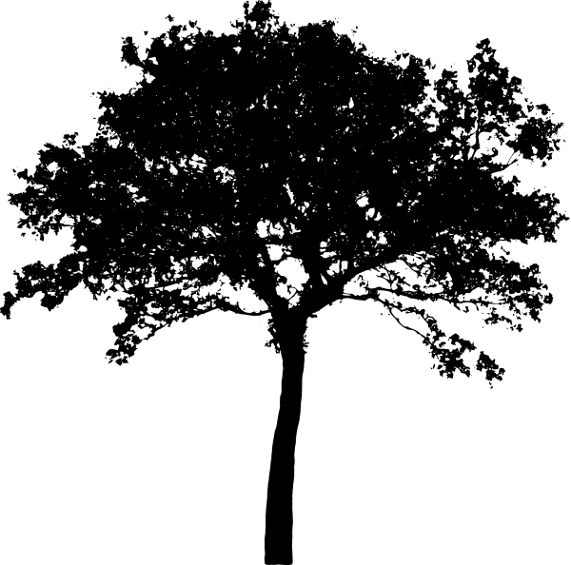

R.E.

We are learning about the importance of the Torah to Jews. What it means to them and how it’s used.

Values for this term:

* Respect
* Thankfulness
* Courage
* Trust

This term all of our learning will be based in four drivers that cover **initiative, creative arts, environment & spiritual, moral and cultural.**

**We will show our initiative by** *being resourceful and working without always being told what to do. Showing both resilience and determination in order to demonstrate that we can think for ourselves and act when necessary.*

**Using our creative skills, we will** *create usable items by sculpting wood and considering the benefit of this.*

**As people concerned with our environment, we will** *looking back at how our landscape has changed as a result of increasing demand for wood and the laws that have been put in place to protect the forests and woodlands. Researching how the forests and woodlands are used by a diverse range of plants and animals to create thriving habitants and what threats these face now and in the future.*

**As part of our spiritual, moral and cultural development we will** *explore how forests and woodlands can be used as places of reflection and mindfulness, helping us to consider our connection with nature. Discuss the moral responsibility of conserving our forests and woodlands. Investigate the different parts forests and woodlands play in cultural storytelling, myth and legend.*

The raw materials that our forests and woodlands provide us with are used in endless ways, they have been and are still a vital part of small and large communities. But it is not an endless resource and it needs to be protected. The pupils will be considering these questions:

* Should we look after the forests or is it someone else’s responsibility?
* What organisations look after the forests and how do they do this?
* Who owns the forests and what does this mean?

*Playscript*

*A Midsummer Night’s Dream by William Shakespeare*

*Poetry*

*The Lost Worlds by Robert Macfarlane*

In role as natural scientists/botanists the pupils will be investigating the plants and creatures found in and around our woodlands. Mapping the life cycles of these plants and creatures, identifying difference and similarities as well as some of nature’s oddities.

The pupils will be stepping back in time to the 16th century and considering what a community living in and around a forest would be like. To better immerse ourselves we will be looking at the Tudor royal family tree and the life of a real Gloucester Tudor. This will culminate in the reign of Elizabeth I and a difficult decision for the class, which relates to the dissolution of monasteries and its impact on our very own cathedral.

*Narrative*

*The Tin Forest by Helen Ward*

Third Milestone:

Whose responsibility is it to protect the forests and woodlands?

Second Milestone:

What has changed in the lifetime of a tree?

First Milestone:

How are forests used?

Year 5/6 Milestone Document

Autumn Term

Launch experience:

Westonbirt Arboretum whole school trip

Synopsis:

As the leaves start to turn and we step into Autumn we will be delving into the forest and woodlands at home and further afield. The class will be exploring the significance of these place in storytelling and legend; as a habitat that sustain a wide range of life; as a vital resource that needs to be protected and a place that can connect us with the past. Part of this terms learning will take place in the form of role-play, as the class imagine they are transported back 500 years and have to face some difficult decisions.

PSHE focus for this term is Relationship:

* Friends and Families
* Kindness and Anti-bullying

Audience:

* Parents & Governors
* Longney C of E Primary Academy
* Ethiopia link school
* DGAT schools