**Computing**

Research information on the oceans and Grace Darling. Using Purple Mash write a newspaper report about the bravery of Grace Darling. Discuss technology that is used to explore the oceans.

NC links:

Use technology purposefully to create, organise, store, manipulate and retrieve digital content.

Recognise common uses of information technology beyond school.

Internet Safety

Are Our Oceans Safe?

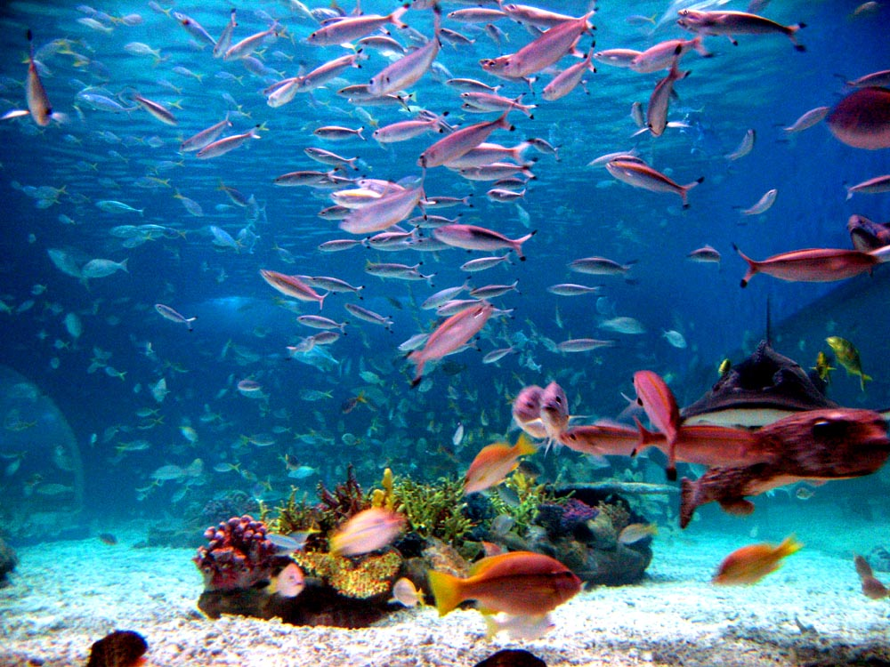

**Physical Education**

Cricket and Tennis

Athletics and Tennis

Music

Your Imagination

Reflect, Rewind and Replay

Oceans, Seas and Rivers

**Design and Technology**

NC links:

Design a lighthouse and a wheeled vehicle to carry food based on design criteria.

Make a lighthouse and a wheeled vehicle using a range of tools and equipment, selecting materials and components.

Evaluate their lighthouse and wheeled vehicles against design criteria.

**Geography**

Explore maps to name and locate continents and oceans. Compare our local area with the area around our linked school in Ethiopia.

NC links:

Name and locate the world’s seven continents and oceans.

Understand geographical similarities and differences through studying human and physical geography of a small area of UK, and a small area in a contrasting non-European country.

Identify seasonal and daily weather patterns in UK and in hot and cold areas of the world.

**Art and Design**

Focusing on pictures of the sea, storms at sea and plants in works of art.

NC Links:

Use a range of materials creatively.

Use drawing, painting and sculpture to develop ideas, experiences and imagination.

Develop a range of art and design techniques.

Finding out about different artists.

**English**

Focus on Reading

Narrative, non-fiction ad poetry work.

Writing stories, newspaper reports, posters, letters and poetry.

Using a variety of simple, compound and complex sentences.

Using correct punctuation.

Proof-read and Edit work

**Science**

Throughout the project we will be planting, caring for and observing a variety of plants as they grow. We will be exploring and comparing living and non-living things in our local area.

NC links:

Plants

* Identify and name common wild and garden plants, including identifying and describing the basic structure of a variety of common flowering plants, including trees. Observing and describing how seeds and bulbs grow into mature plants. Find out and describe how plants need water, light and a suitable temperature to grow and stay healthy.

Animals, including humans

* Describe the importance for humans of exercise, eating the right amounts of different types of food, and hygiene

Living Things and their habitats

* Explore and compare the differences between things that are living, dead and things that have never been alive. Identify and name common animals including fish, amphibians, retiles, birds and mammals. Identify and name common animals that are carnivores, herbivores and omnivores.

History

Seaside’s now and then, how are they the same and different and how things have changed. Pirates on the seas and Grace Darling, her actions and the .

NC Links:

The lives of significant individuals in the past who have contributed to national and international achievements.

**Maths**

Number Presentation of Data

Shapes Problem solving

Measurement

Addition and Subtraction

Mathematical movement

Time

**Religious Education**

What is the Good News Jesus brings?

What makes some places sacred to believers?