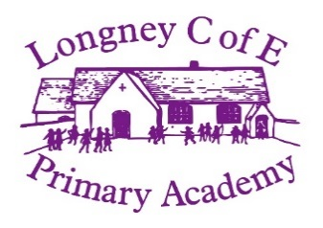

**Learning:**

Over this term we will be exploring Antarctica. We will look at what species live in Antarctica and how they survive. We will investigate why Antarctica is important to our planet and how we can help protect it.

Welcome back Swallow class.

We hope you have had a fantastic Christmas.

**Swallow**

**Newsletter**

**Term 3**

**Reminders:**

* PE on Thursdays and Fridays. (Labelled PE kit needs to be in)
* Drinks bottle of water.
* Forest School will still be on Thursdays. (Labelled waterproofs and wellingtons)

**Dates for the diary:**

16.1.20- Skill zone trip (MORNING)

21.1.20- Birdland trip (ALL DAY) – pack lunch needed

23.1.20- Forest School

**Helpers**

We are always looking for parents to support children whatever your skills. Please speak to Miss Wilce or Mrs Tranter if you feel you can help. This could be hearing children read, or support with cooking or craft activities in school time.