**Art and Design**

Focusing on sculpture in the environment, looking at the work of Andy Goldsworthy.

NC Links:

Use a range of materials creatively.

Use drawing, painting and sculpture to develop ideas, experiences and imagination.

Develop a range of art and design techniques.

Finding out about different artists.

**Geography**

Explore the surrounding area of the school, including its physical and human features.

Explore maps to name and locate continents and oceans. Compare our local area with the area around our linked school in Ethiopia.

NC links:

Use simple fieldwork and observational skills to study the geography of our school and its grounds and the key human and physical features of the schools surrounding environment.

Identify seasonal and daily weather patterns in UK and in hot and cold areas of the world.

**Design and Technology**

NC links:

Design a shelter to observe animals in a habitat.

Make a model of the shelter.

Evaluate the design and the model, changing and altering the product to improve it.

**Computing**

Use technology to explore our local area.

NC links:

Use technology purposefully to create, organise, store, manipulate and retrieve digital content.

Recognise common uses of information technology beyond school.

Internet Safety

**Music**

Hands, Feet, Heart

Nativity Play

**Physical Education**

Multiskills and FUNDS

Multisports and Dance

**History**

Explore the changes in Longney over time including houses, farming, jobs, etc. Focus on Queen Elizabeth I and Queen Victoria, how these monarchs were the same and different, how they effected the lives of everyone at the time.

NC Links:

Changes within living memory.

The lives of significant individuals in the past who have contributed to national and international achievements.

**Science**

Observing the weather and discussing how it changes through the seasons. Identifying trees and exploring habitats in forests. Finding out about materials, especially wood, to discover their properties and what they are used for.

NC links:

Observe changes across the seasons.

Observe and describe weather.

Identify and name a variety of deciduous and evergreen trees.

Identify and describe the basic structure of trees.

Identify and compare materials and their suitability.

Identify that most living things live in habitats to which they are suited, name the plants and animals in the habitats.

**English**

Focus on Reading

Narrative, non-fiction ad poetry work.

Sentence work – orally rehearse sentences before writing, using capital letters and full stops. Year 1 naming people, places and things in their writing. Year 2 writing simple expanded noun phrases to describe and specify.

Writing sentences, beginning to write stories, posters and poetry.

Proof-read and Edit work

Why Are Forests Important?

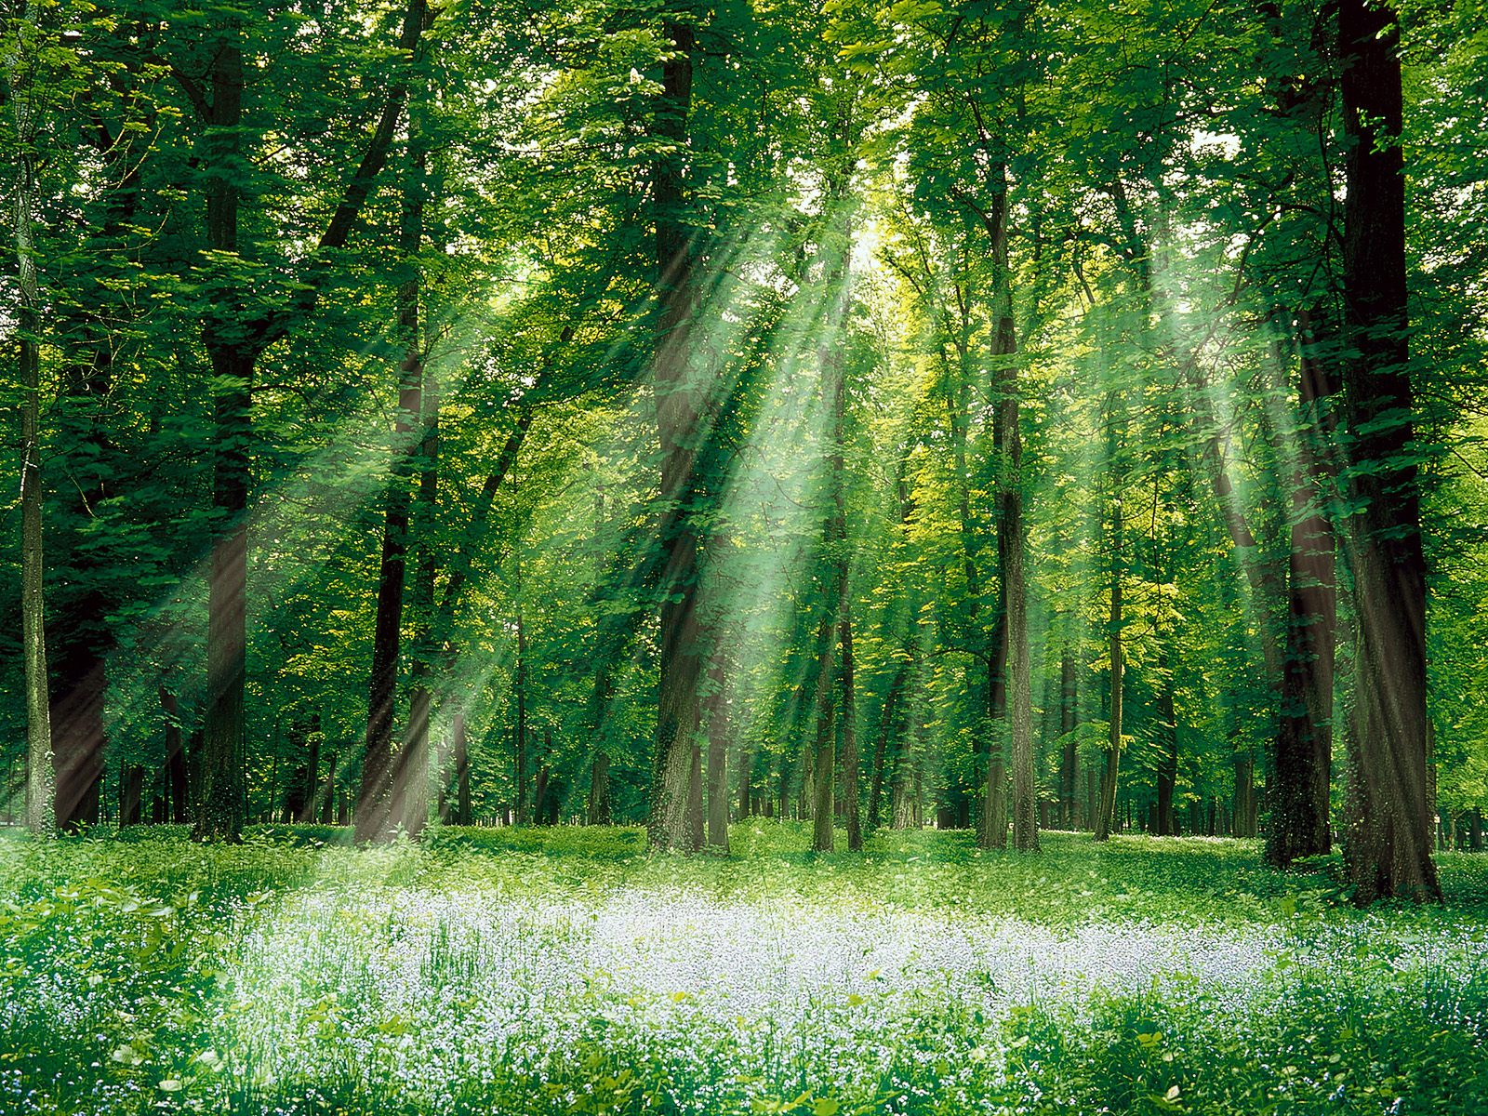

**Maths**

Number and Place Value

Geometry – Properties of shapes

Addition and Subtraction

Multiplication and Division

Position and Direction

**Religious Education**

Who do Christians say made the world?

**Harvest**

What does it mean to belong to a faith community?