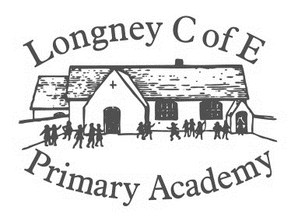

Synopsis

# Skylark class will be learning about the oceans, where the oceans are on our planet, what is in our oceans, how to stay safe near water and who keeps us safe when we are on the oceans. What we can do to help protect the life in our oceans.

Outcome

To better understand how we can stay safe when near or on the sea or oceans. To have a positive effect on the local environment by removing plastics. To tell others how to reduce their use of plastics.

Values: **Friendship, Forgiveness and Service.**

RE: What makes some places sacred to believers?

Key Question: Are Our Oceans Safe?

**Ethiopia** What is the landscape like? Does Ethiopia have a coastline? What is life like for the people?

How can we stay safe in the Oceans?

RE: What is the ‘good news’ Christians believe Jesus brings?

PSHE:

Media influences

Financial capability

RSE

British Values and citizenship

Internet Safety

Launch:

An interview with the bear from the story The Sea Saw.

Initiative

**We will show our initiative by:**

When designing we will explore different ideas from books etc. We will decide on the tools and materials we will need to design and create our lighthouses.

What is it like by the Sea?

Where are the sea sides in this country?

What is the seashore like, is it always the same?

What can affect the changing coastline?

How have the seaside communities changed?

What might we find on a beach?

What did pirates do?

Where did pirates travel on the oceans and why?

What plants would we grow if we were shipwrecked on an island?

How can we stay safe on a seaside beach?

What are the hazards on a beach?

What are the flags on a beach?

Who is Grace Darling?

How did she show bravery and courage?

How do her actions affect us today?

Where are the lighthouses today?

What organisation rescues people today?

Who is the RNLI?

How to they help us?

Where along the coast are lifeboats located?

Why have they been located in those particular places?

Who lives in the Oceans?

How long is the journey that elvers take to reach our river?

What oceans do they travel through?

What other life is in the oceans?

Is every ocean the same habitat?

What is the Barrier Reef?

What is plastic pollution?

Does plastic pollution affect the oceans and their habitats?

How can we help to improve the environment?

How can we encourage people to reduce the use of plastic?

What can we create to remind people that plastics should not be in the oceans?

Spirit, Moral and Cultural

**In our spiritual, moral and cultural Development we will:**

Explore the feelings that we have when we hear stories of bravery and courage. We will learn about different emotions that we feel when people help us.

Creative Arts

**Using our creative skills, we will:**

Explore pictures of storms and the sea. We will be painting pictures of the of stormy seas and adding, sand and other materials to our paint to give different textures.

Environment

**As people concerned with our environment we will:**

Find out about coasts both in this country and in other countries. We will find out about how some coasts are crumbling into the sea and what people are doing to try to stop this.

Opportunities for Critique and Redrafting:

Lighthouse designs

Poster to encourage others to reduce the use of plastics

Audience:

Our School Community

Parents Celebration Worship