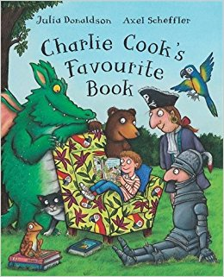

**Value**

Perseverance and love

Charlie cooks favourite book

Swallow class

Term 4

2018

**RE**

Why is Easter special to Christians?

**Mathematics**

* Number recognition to 20
* Estimation
* Can say one less and one more then a given number
* Add and subtract 1 digit numbers.
* Coin recognition
* Comparing weights

**Computing**

* What a computer is and what they can be used for?
* Talk about their use of ICT and other ways of finding information
* Understand that different tools are used to navigate computers
* Use simple programs on a computer/tablet.
* Print work from computer.

**Communication and language**

* Listen attentively in a range of situations
* Listen to stories, anticipating key events and responds to what they hear with relevant comments.

**Expressive arts and design**

* Sings a few familiar songs
* Initiates movement in response to music
* Experiments mixing colours.
* Uses different materials to create texture.
* Builds stories around toys
* Chooses particular colours to use for a purpose.

**Characteristics of effective learning**

* Finding ways to solve problems
* Testing their ideas
* Have their own ideas
* Uses senses to explore the world around them.
* Showing curiosity about objects, events and people.
* Maintain focus on their activity for a period of time.
* Initiating activities.

**Literacy**

* Read and understand simple sentences.
* Read tricky words
* Write and use tricky words in their writing.
* Use their phonic knowledge to write words.
* Write simple sentences.
* Join in with repeated refrains
* Say how they think a story might end.

**Understanding the world**

* Children talk about past and present events in their own lives and in the lives of family members.
* Children talk about similarities and differences in relation to places, objects, materials and living things.
* Children recognise that a range of technology is used in places such as home and schools.

**PSED**

* Play co-operatively, taking turns with others.
* Confident to try new activities and say why they like some activities.

**Physical development**

* Holds pencil effectively.
* Show good control and con-ordination in large and small movements
* Moving confidently in a range of ways, safely negotiating space.