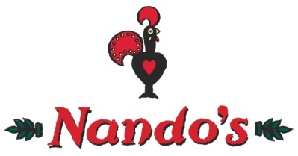
Swift Class Take Away Homework
Choose your homework from the menu below:
Your goal with this half terms takeaway homework is to earn 70 points, if achieved you will receive a reward. Ensure all work is completed and handed in by Thursday 19th July. All work must be stored in your homework folder, tasks can be done on either computer or by hand. Unless specified, doing two of one task does not mean double points! I am looking for quality therefore points will be deducted for poor presentation.

Maths/English | Value | Topic
English – Write a dream diary, using the questions you have been given as a guideline for what to mention. This could stretch over two weeks if you don’t have much to record the first week. (25 points) | Values – Friendship and Truthfulness, create a fable that teaches the moral lesson of this terms values (15 points) *COMPULSORY TASK | History – Research one of the ancient civilizations (Egyptian, Sumerian, Shang or Indus Valley) we will be studying this term. Make a report showing your findings, this could be a poster, pamphlet or fact file. (25 points)
Maths – Complete a ‘Geometry Makes Sense’ pack, see Mr Hanrahan. (20 points) |  | Science/History – Research and write a bio on one of the ‘Women in Science’, see Mr Hanrahan for a list of names. (20 points)
Reading – Interview family and friends to find out what they are reading at the moment. What’s is the book about? Are they enjoying it? Why? What have they learnt from the book? And any other questions you can think of. (15 points) |  | Computing – Create your own code (like binary) using number, letters or symbols for the alphabet. Then write a secret message to be cracked. (15 points)
English – Complete a vocabulary list, see Mr Hanrahan. (10 points) |  | D&T – Help to make a meal at home using an ingredient that is grown or produced in the local area. Write a set of instructions/recipe to follow for the meal (pictures would be great). (10 points)

