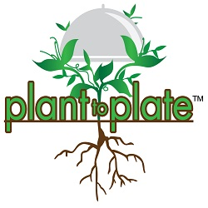

**In P.E. this term Swift class will have Gymnastics on a Tuesday (Year 6 only) and Cricket every Thursday.**

**In Computing we will be talking about keeping ourselves safe online when communicating with others and how to identify and report cyber bullying. Swift class will also become ‘Code Breakers’.**

**In PSHE Swift class will be learning about living the wider world and the various rules, rights and responsibilities that affect them and others.**

**In English this term Swift class will be:**

* **Looking through the ‘The Viewer’ by Gary Crew. Analysing its imagery and developing our own stories based on this mysterious picture book.**

**Topic Links:**

* **‘Food shortage/famine’ Recount.**
* **‘Donating to a food bank’ Letter.**
* **‘How to make a healthy snack’ Instructions.**

**This terms topic work will focus on Human Geography, looking in detail at:**

* **Human Settlements.**
* **Exports and Imports.**
* **Fair Trade.**
* **Water Distribution.**
* **Energy and Resources.**

**In Science we will be investigating:**

* **Blood and the Heart.**
* **Circulatory System.**
* **Nutrition.**
* **Healthy Bodies.**

**And in Design and Technology we will be building a decorative box to store the viewer from our English unit.**

**In Maths this term Swift class will be covering:**

* **Geometry, specifically in the areas of angles, shapes, position and direction.**
* **Units of measurement, both metric and imperial and how we can convert between the two.**
* **Area, perimeter and volume.**

**Topic Links:**

* **Drawing an accurate net for food packaging.**
* **Monitoring the miles my food has travelled.**