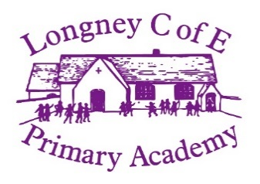

**Swallow class newsletter**

[](https://www.google.co.uk/url?sa=i&rct=j&q=&esrc=s&source=images&cd=&ved=2ahUKEwjh9qzc2OrhAhV55eAKHQpuAhAQjRx6BAgBEAU&url=https://www.amazon.com/Craft-Rolls-12-Pack-Cardboard-Crafts/dp/B07CBNQNV5&psig=AOvVaw1IKI1GEJefjNPFsi62cMG2&ust=1556262680732894)[](https://www.google.co.uk/url?sa=i&rct=j&q=&esrc=s&source=images&cd=&cad=rja&uact=8&ved=2ahUKEwiWoduK2erhAhV77OAKHcqLBigQjRx6BAgBEAU&url=https://discovernight.com/products/night-dual-sided-pillowcase&psig=AOvVaw0ZyWJuR_nyn_ShMSoOUML-&ust=1556262859273802)

**Swimming**

Swimming will be every Friday for the next 5 weeks.

26.4.19

3.5.19

10.5.19

17.5.19

24.5.19

**PE**

PE is still on a Tuesday afternoon and Thursday. Please ensure your child’s PE kit is in on these days.

**Requests**

Please could you send in any cardboard rolls you might have at home? And an old pillow case to be decorated as a flag.

**Forest School**

Thursday 25.4.19

Thursday 16.5.19

**Homework**

In your child’s message book you will find the home-learning for term 5 and 6. We are having a real drive on reading and are asking the children to read a couple of pages daily at home, get their reading records signed at home and bring them into school to be checked. We are going to be running an incentive all children who read and have their record signed every day will have an extra 10 minutes playtime on a Friday.

We are looking forward to our new topic this term, ‘Are our oceans safe?’ Please keep an eye on the website throughout the term as we regularly post photos of what we have been doing in school.