**Maths**

Place Value

Multiplication and Division

Shapes

Fractions

**Religious Education**

Who is Muslim and how do they live?

Why does Easter matter to Christians?

**Physical Education**

Dodgeball and Swimming

Rugby/multi skills and swimming/dance

What’s Out There?

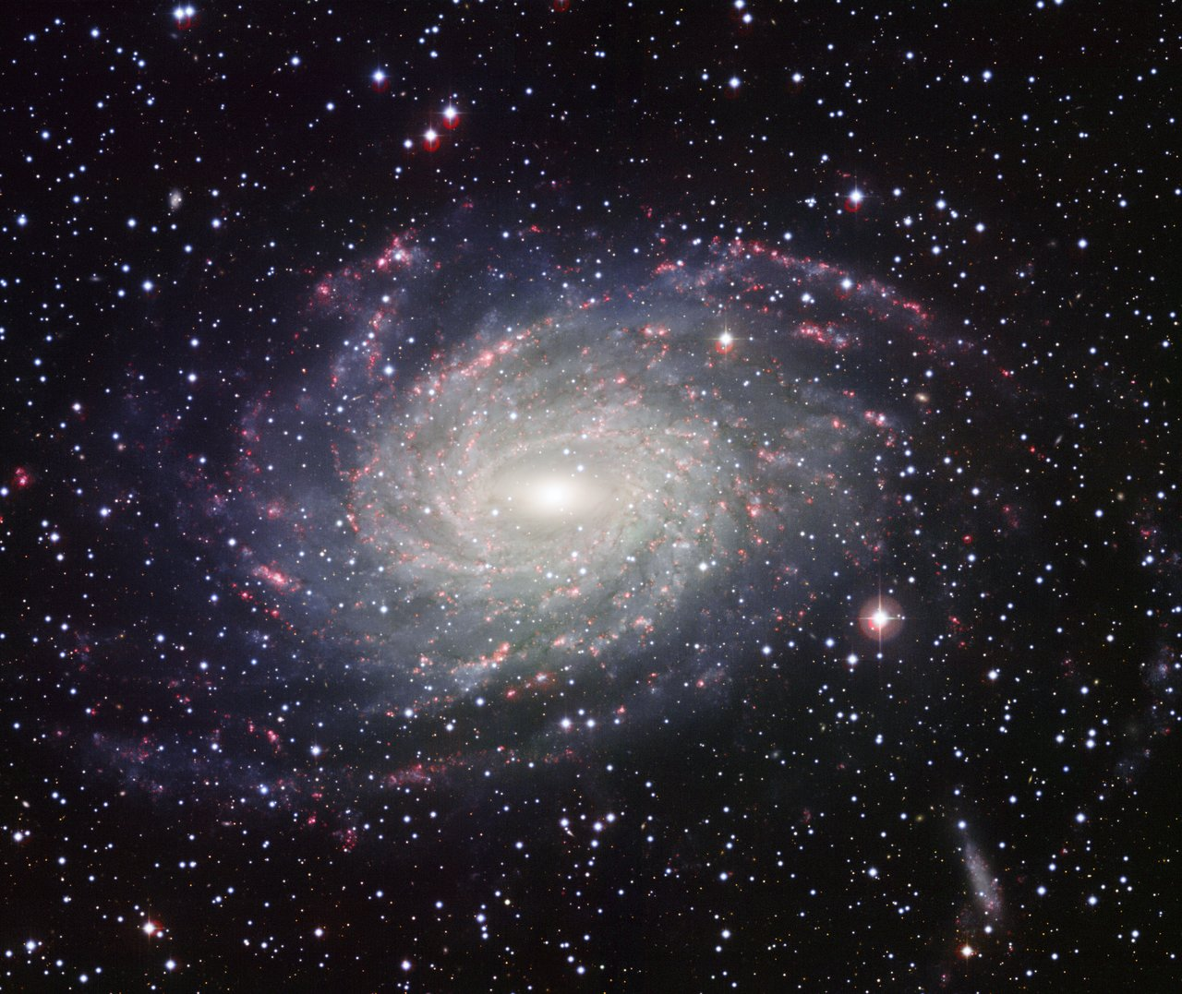

**Computing**

Algorithms

Create and debug simple programs

Use logical reasoning to predict the behaviour of simple programs

Internet Safety

**Design and Technology**

Design a moon buggy based on design criteria

Make the moon buggy using a range of tools and equipment, selecting materials and components.

Evaluate their moon buggies against design criteria.

**Geography**

Name and locate the world’s seven continents and oceans.

Name, locate and identify the four countries of the UK, including capital cities.

Identify seasonal and daily weather patterns in UK and in hot and cold areas of the world.

**Art and Design**

Use a range of materials creatively.

Use drawing, painting and sculpture to develop ideas, experiences and imagination.

Develop a range of art and design techniques.

Finding out about different artists.

**English**

Focus on Reading

Narrative, non-fiction ad poetry work.

Writing stories.

Using and writing questions to inform an audience.

Using and writing sentences with exclamation marks.

Use a capital letter for names of people and places.

Music

In the Groove

Rhythm in the way we walk

The Planets by Gustav Holst

History

The lives of significant individuals in the past who have contributed to national and international achievements – Neil Armstrong and Christopher Columbus.

**Science**

Seasonal changes

* Observe changes across the 4 seasons
* Observe and describe weather associated with the seasons and how day length varies

Animals including humans

* Identify, name, draw and label the basic parts of the human body and say which part of the body is associated with each sense.
* Describe the importance for humans of exercise, eating the right amounts of different types of food, and hygiene

Living Things and their habitats

* Identify that most living things live in habitats to which they are suited and describe how different habitats provide for the basic needs of different kinds of animals and plants, and how they depend on each other.