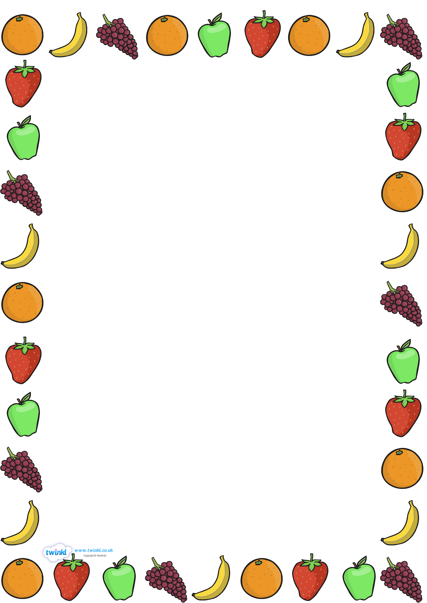
Home learning for Swallow Class
‘Food glorious food’
These are some possible home-learning activities for you to have a go at. Please do not feel pressured to complete all of these activities, simply pick and choose according to your child’s interests and most of all have fun. We would love to see any work your child would like to bring in.
Outdoor learning | Grow some plants or vegetables. Watch them grow, what happens to them? | Help to look after the garden. How do we look after our gardens at home?
Maths/ Literacy | Help to write a shopping list for your grown ups. What food types are on your shopping list? | Count how many fruits and vegetables you eat in a week. How many were fruit and how many were vegetables?
Shared learning | Read a book on the active learn website. | Help create a meal with your grown ups.
Communication | Play eye spy. | Talk about what you found difficult/challenging in your day/days. Why was it difficult/challenging?
Creative learning | Create your own super hero – fruit or vegetable. | How would your super fruit/vegetable capture a baddie?
Don’t forget to carry on reading the books we send home, practising high frequency words and your precursive handwriting sheets. When you do one of these activities please remember to write in the message books!
Happy home-learing!



