September 2019

Homework for Swift Class

Dear Parents,

Please see below the nine tasks/activities, containing all the topic homework for both Terms 1 and 2 (from now until Christmas). The task increases in complexity as they move from left to right, requiring more time, research and thought to complete.
Children should choose six of the activities to complete, to be done in any order and brought into school on the dates shown below. Each completed piece of work (or a photo of it) will be stuck into the child’s Learning Journey book, so please remind your child that it needs to be well presented.

Children will also be set ten weekly spellings, these will be set each Monday and be tested on Friday. A practice sheet will be sent home on Monday to reinforce the learning that takes place in school, this does not need to be returned to school.

Lastly, children will be given (again on Monday) weekly Maths homework. This will be on either:
https://ttrockstars.com/
or
https://www.purplemash.com/sch/longney
It will vary from spending a set amount of time practicing fluency skills or a specific task. If children have issues accessing either site at home, time will be given in school to complete this.

Any questions, please ask.

Yours sincerely,
Mr Hanrahan

Topic Homework Tasks

Task 1 – due 23.9.19
Task 2 – due 07.10.19
Task 3 – due 21.10.19
Task 4 – due 11.11.19
Task 5 – due 25.11.19
Task 6 – due 9.12.19

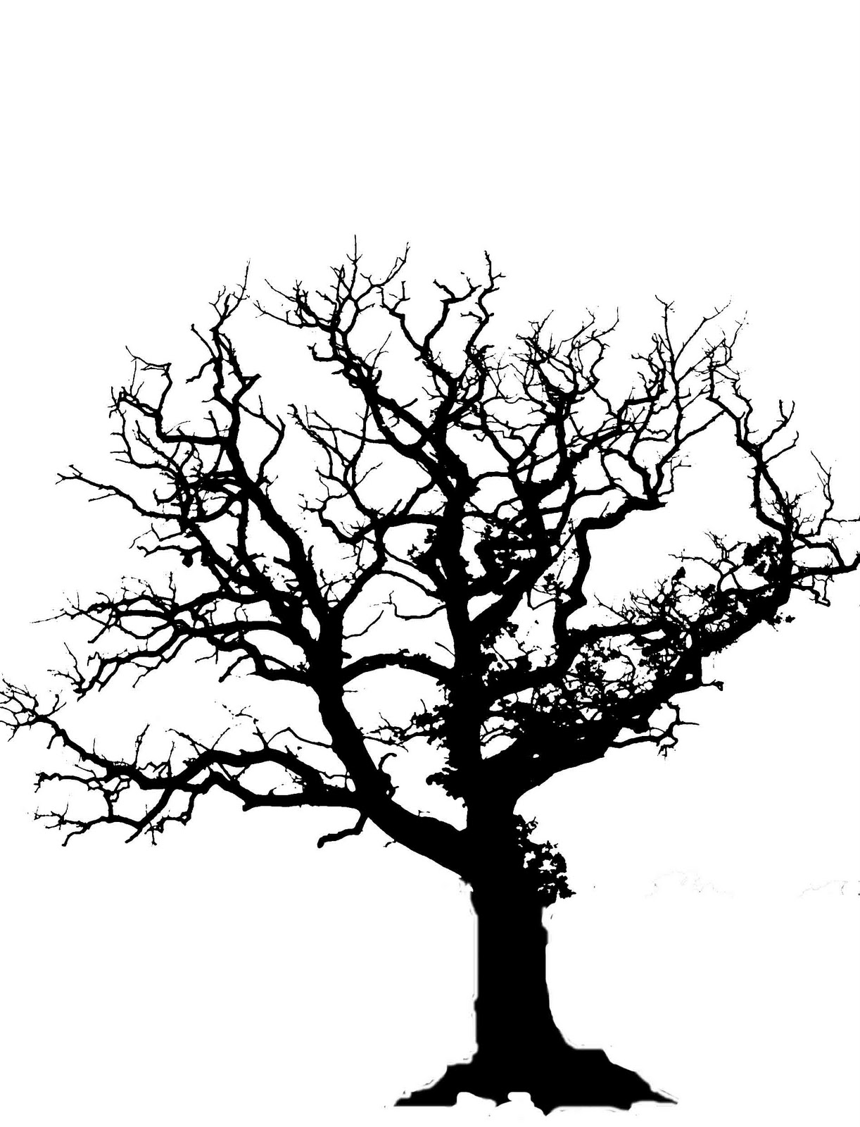
Research and find a poem you like about forests or woodlands. Copy the poem out in your own handwriting. | Compose a shape poem, in the shape of a tree, about forests or woodlands. | Collect leaves from 5 different trees, sketch them and put a fact about the tree it came from next to each sketch.
Grow a plant at home and record the progress, from seed to plant, with photos or sketches. | Create a sculpture using materials you would find on a forest floor. | Write a fairy tale set in a magical forest. Remember to include fantasy creatures and a hero/heroine.
Research your own family history and create a family tree. | Measure the circumference of a tree at home or in a local park and use this information to research how old it is. Record your findings. | Research the life cycle of an amphibian and an insect. Create a poster showing your findings.

